-

' C

l) A~ Lt 5"l

*J S~=* A *-L*

JT *=* qoo k.- 100 1( -:: bOOk -

*r* \\ *()* - ~' \., \ ' i) v°'-~ *Go /V'* Mo " *st-o Gil*

*I r* + t,oo t:l_ - + *fooo*

*I* ~~-~~

. . ~- -

*~] [ os~ . (* oter- *D°'-*Y°'~l e.- ---

- -t"\1-000 *I* ~\z.poo

? ~~--~~ 4/ ~~-~~

CQ.r\.-- er Vl(fV'~At __ *{\Q* te'.S' . (.)G. *'{* Q's' e; _,_  --

;,....

.

- ( *,otJCJ* ~& [)t;>O -+ *7 ,000* ~~..~~ ' ' *I* ·- 0 '

.

-

*SJ* D, *C.c>.J~* 4-, on o

*Cr G0r--Dr-* .SJot.,l/__ t, '.)l>'::I ~~-~~ ..,..  *f)* Dr *l r:>-s\.,.,,* IL, DO 'i) ~~-~~ l, *Nr:1h;- ()a..* v o..b \ 0 111 i)CH) 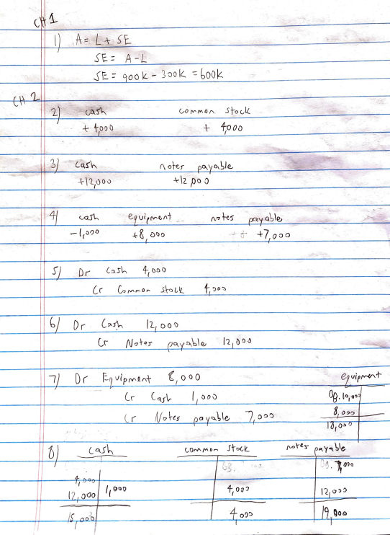

\ - ..

*r)* Dr l=-9 *-Ji p* (¥'1 AT *(* O oo

*I e7 vifrv--V'* t- , ~~-~~ ., *(_, C1.f* 09. t:,") *\r* I, Dov ( *( (lj O ~i:f () o.* V <:)\ *\e,* ~~l,~~ ~O'J *~~a,~~ o~o*

*L* ~~I ~,o.!>~~ I_J . -

*oJ* C *a.S""* CQr-f\. *I"'* o ,..., stoe,t_ *(\, 0 \-£~* f ""' y"\ b\e ------r-- I

I *I I* I' ' n ~~l~~

I t-; . -

,_} ~. 'd " *~~.'~~1> ~~.~~* ~~f~~ *Ol)o*

*~~( V~~* ~~V~~ *I (* (;)QU 17, *ooo* 1'2.ro :>0

| f *OO'.J* ' |
| --- |

*1 I*

'! *I I* /£. ,,..,_Jo I *4-* oQ<::> /~ f ~o e *1* I

*!*

l\\ *J* JqA *3* Dr Af', 'L -!) ?'.) *Dr Cas'h* t_;),:> *ti*9) r -(;I/ *tf\ \J* .../ 3rd

r ~ "JI\ *l?:e;d* \] 0. 0 (,.r .. C,.\u *Jl?...v(.,rrJ~* v *u ft(<_* **2,.0 1**, *I J* ? *Sq" 'l'*

*~ - e_g_fer£'l, r e.l--Dj f\ i* ***ht*** .-- ***3rc* Vl1i<'** Pr ***l,o,..fr/>,J Jon* t ll, f oo** At *fo ?* ,J ~,., *Dr*

*I* I

|  |
| --- |

(,,r Ar ***lo~*** *u* ( ,;u'l,.,_ **j'o**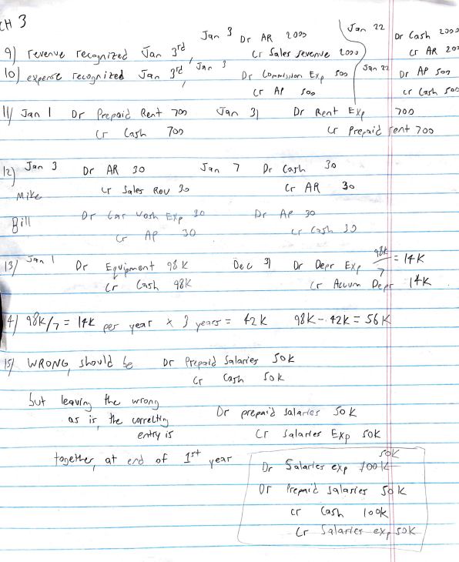

\ \/ .Jr.{(\ I D, Pr-e.pa,~ **({lAf-** *1DrJ* 0"°'1 0 JJ *Dr (l...ent* E: *k'. ,* ,oo ***J* l:** *~~('~~ (_,,,f ir,* 700 Cr *f r-el' r::..i'e, e/\+* 700

lf1 **JQ("'\** J *Dr* Al\ *Jo s* q i"\ ~~'~~ Dr CQ\rL-- *] 0*

*J s~* le1"' *J'9* Cr Af\ **3<:)**

*-M-?:i-~* Lr *«e-v*

*D-r< l P* r~ 1~~r~~ io ~~D~~rA *~~e.~~ ~~3~~"*7'1~~(~~ I

c;-

**1H**

~~A~~f ~~3~~ 0 *(__( c~.f\-.* j ,')

*11) _)* "t" \ *Or* -- .'.3) *~~·w,~~* : ~~/t~~ k

~~'~~ E~~11~~ v~~<~~~ ""~ t 9t 'Di *u Dr* ***Oepr*** *E-x,* ,,;,-- ***V* 7:** I *{*

~~.,,~~_ *~~l r~~ l-'7\s-k* qi k *r,* ***A-l v V""'*** *De* :·1+iz I

*14-/* f/lt_/7 :: ***ltt*** *µlf* l:f eP\ r ,\ *J* yea. *rs* ::- f-2 *k_* 9 *g* k -, t 2 k. =- *s* b *r* ' I

II

*(<* 0 **{V** *G 1*

*_s lr-o \J \t* D, PrlPct l J *5°'* l~r<' e:r J C) k. ~f'h c f c:, l

,

sur leqvr ", k w-ron f\

--.J ......, *T>r prt f A1't,* JoJ.~ r(e .f *S~~ot~~* . *~s* ' *1k ~~v0rrt L:H~~* ~~"'~~ I f"  I e#y if l r *J* lo. r< ~/' r- *.Xp rot*

*+o~€Jt1-u* 1.r+ oJ *e/'6* of *v e~ , J< I* I ~~u,:--~~~ 0. 'i.Q, ~~Ff~~ C: :r' ***~~ex.r~~*** ~~l~~~

*J ~~vr~~ frc f~./[, J'\\~des* -· •'

| l( r *s )(_* |
| --- |

*)* c.r (C\f"' *I <)* Dk_ C ~~-~~ *~~L,~~* ~~-~~ *~--ll-~~\~~~-~ ~ v* ~~'~~ r" L / *~~_~~ ____J*

**- - 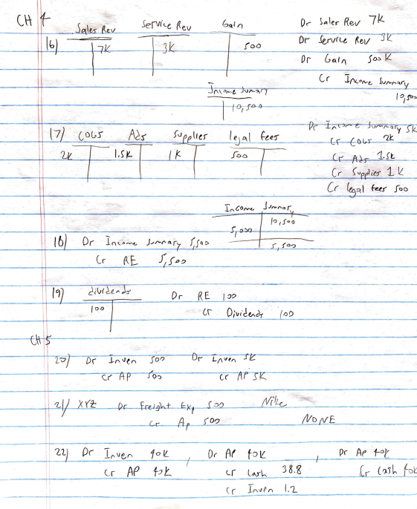

*Cr* If\<,011,--l, Jv,,,...r,",..v

***.J(\\ D,.._t*** J \J/\--'>, I 7 l *i-etf-*

*?Y* 

I *(*

I *Cr (t'.Di~* I *f~J' Jo* C)



----.-1--------------,~ ,~~-l--f----~------ I *6)* Dr In~-"""<, *J..,r--l'o.r7 f,f<i !>*

I r -

/o *I* J"'/J

i



--------------- ! _ I *0°* C, 0;11,·~tA.:?-r *(* 00 ---~1+-- --- -1---------- 

I I **(91** *1/ 0* r RE I O!>

J

t \\ \)

' *£)(* l-0 *'1(.r, *

*C(* f-fP *s~~'o'.)~~  *

I

___ '21) *{)r-*_I" Vt!J,... *1·0* ,, *Or* A~ *'-o IL* Dr AP *LolY* __,_r-----• *· _...:;; v_' , ___ lt'....._ f_* --~ - ( ---/-- I / . ***L*** Cr *AP f :1 t* c_r L"',-l--_ 3 *B* · (.r_l!}Y~ fat---

e. r *Ir.\J R,..,* I, *'L.*

- 1-J} *~~0(~~* AR ~~,t~~ *Or* LDG..f 2cf OQ *J* ~~er~~ SQler- *~(A/* 7k. Cr ***J.,-,.v.fr,,*** -~ *Joo* 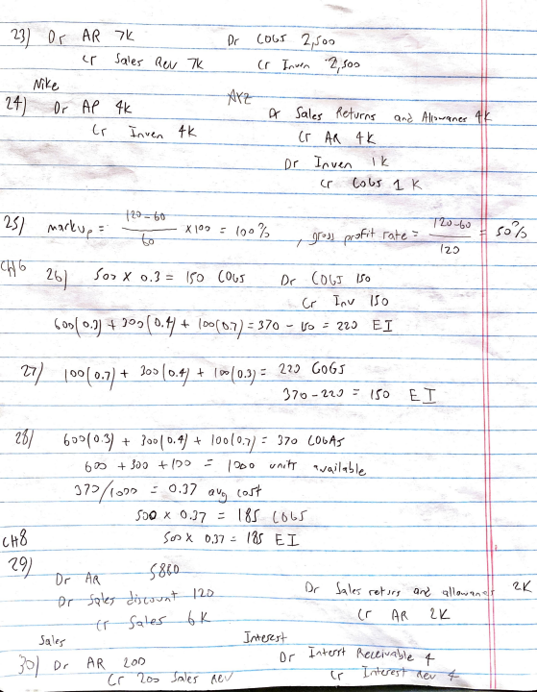

*f*

- *(V(Y-e,*

-foY,-t ~~'Lt)'-·~~ *~~~o(~~* ~~Af~~ 1-k- JC\le! *~e+vrf\~* A-1{'>....,.'-l"e,r - *0(* Q"~  *~~L,~~* ~~l(\~~ V{,A ~~tk~~ Cr *A;f* t t

. *Or* ***lf'* V~/"\** It

~~";,.~~

- Cr 8,'.) *Gs* 1.. K

¥

*\V> ~~25)~~ ~~r?~~*

**oU**

*I) ~~I Li>~~* ~~~<:iv~~ *"""'r'l.\) ~~c ~~~* Io /2 *~~-~~* x. 100 ~~-~~ *(o () /-:,* or" JJ *or:JFd-*-roJ-e. -:- - ~~b~~ *~~I~~* I (2:> ([b 2- ~} *fo') X* 0. *'J* - lfo (0tir *D"* ( ()~T /Jo *I* - . ... l 0 v *!So* . *Cr* l ol)( ().'J) 4- *)o')* t>. *1i* + (Do ~t)l}:: *370* - lfo *-= 'Z'l-J* E. T

\ 7 t , *7*

*1:7)* 1~0 ~0.7 ) + ;o~ ( o.+/ + (oo (o.3) :: *1_ 7.:) GoGs*

*r ~~T~~ r )* 7\0 _ *1,1_:;* ::- 1.ro E... i

*zi;* tJO'J(O .'!)} + Joo ( 0. ***-tj*** -\- /oo *( o.,J ::: 370* **l,Obftj"**

+ *Juo* ~~+~~ (1)0 ~~-~~ 6 O'.:) ~~-~~ I Ot>O *u-11,'f-r* ".;o.J 1 s le,

J 7 *J /(* orJO O,J7 *0* VC) corf

-

*SDO X* O.J7 -- l~f l6~f

c\13 )oO **'x.** 0.37 ...:. *tis* E,j_ ~~;~~ 1-9)__ )-&lD - *Dr* Ar.,_ Dr ~~Sa..\t-s-~~ *~~,~hr, ar-c,~~* ***~~·q\\o"""'"~~ ""*** *"L~* ' - 1').!') *Dr---5q-\t~ :..r~ 5'~~* ~~(_r~~ ~~0·f~~ ~~2JL~~

*5a.\es-* 1/\"""e.fl.J+ - - - *Or I /\hrf+* ***(\clf,i* v 4-\.,\ *e,_*** t *__ J~)* D, AR 2_,.o O ~~1M~~"ZTerh~v *1=* - Cr *7[0 -:::,* Jr:,,ler *t-.iv \_ (*

~~"~~ ~~J1~~ l ~ 1:\5~ ' Dr *'Z 0~* 0

'

*)1)*

10 r _f *e_rv ( lb* C~'\r~ <- *~x_( ('l.* 0 (.,(' *(\e,v* 3~

*~~J~~ Dr ~D E* 1tfu *Qr Ao?t (l.* l, AD~ 14-o (.r Af\ *lit.*

*D,* A~ 4t

"o'

lr f\0/\ f k_

*3))* (>() lo

*Or ~0£* 4-9. *( k_*

, *Cr A-oA-* 41.( t *~~14 .S~~* ~~t~~ CD _'=- .. *exi* ~d.j -.1 f1""~ ~~t~~ 

I ~~s~~ *<!i* 19. ~~r~~ J<..

I

, I ,

-7 ~~3f/~~ *~~Dr~~ ~~C~~l}.. ,;~~"'~~* ~~l~-0~~ *~~l~~z.* --

\ Or *~e.r/Le* C,V\4 f"o *l., 3,21<*

~~I~~ lr *~~A~~f* __, *~~80~~* ~~K~~ I

-

D. ~( 'lo *; O!J'JI* J4oJ__ 11-.-t2~~--------~~- *__ ,L-S o, .t:JDO* .J..- *(~o f* v'J')/-i,___ __________ _ *1* 

36 36J ,.JJl - *1-.* 9 - I

T3V )( *6-=t* = Gf *1-s.s* JO.? *(* O~I )( 0,0 / -J~;f *J*

*r1 F-V* I

*-P r* l;\-1rrrr ~~·e-c~rUiX1S1 *e_ ~ -?:f-:f* t l\\ \=u-tr+- *r-..~v (; f t'IS.* r